

AHU CONTROLLER TEST DATA SHEET

P/N: AHU-L (47) 413-8005-1 Date: 11/04/2018 Time: 16:26

S/N: 287 Tested by: fd

Hardware Rev: BLDC_60A_V6 Approved by: fd

Software Rev: 5.3.9

Tester Software Version: 1.2j

Equipments Used

Equipments Model No Serial No

Power Supply

Digital Multimeter

CAN Interface

BLDC Tester

PC

Heater

RS-232 Interface

Current Meter

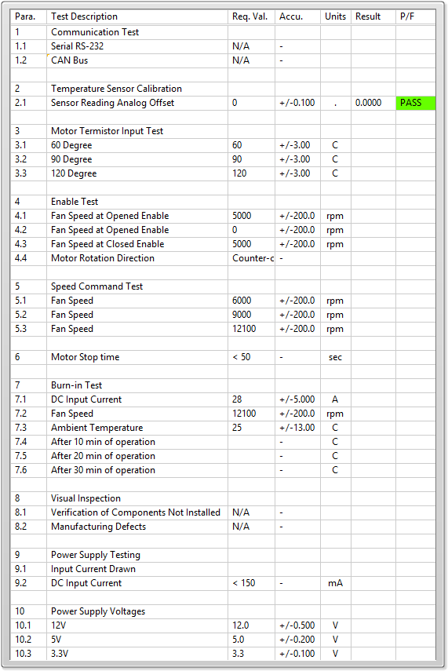

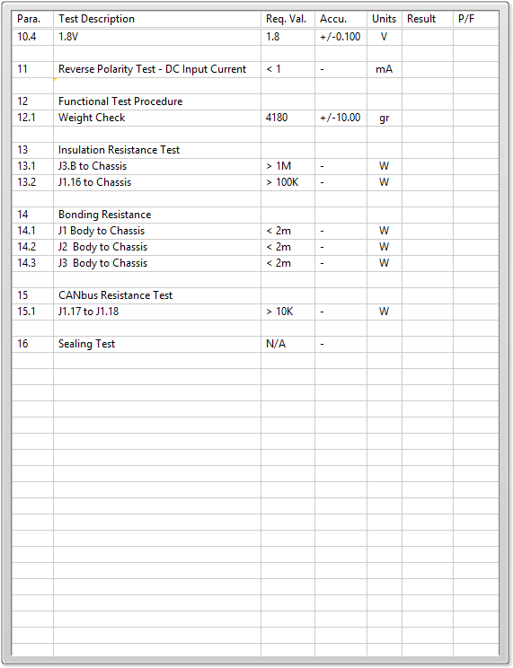

General result:

Test-Operator:____ fd_________ Q.A.:__________________________